SCHOOL OF COMPUTER SCIENCE AND ARTIFICIAL INTELLIGENCE |  |  |  |  | DEPARTMENT OF COMPUTER SCIENCE ENGINEERING
Program Name: B. Tech |  |  |  | Assignment Type: Lab |  |  | Academic Year:2025-2026
Course Coordinator Name |  |  |  | Venkataramana Veeramsetty
Instructor(s) Name
  Dr. V. Venkataramana (Co-ordinator)
  Dr. T. Sampath Kumar
  Dr. Pramoda Patro
  Dr. Brij Kishor Tiwari
  Dr.J.Ravichander
  Dr. Mohammand Ali Shaik
  Dr. Anirodh Kumar
  Mr. S.Naresh Kumar
  Dr. RAJESH VELPULA
  Mr. Kundhan Kumar
  Ms. Ch.Rajitha
  Mr. M Prakash
  Mr. B.Raju
  Intern 1 (Dharma teja)
  Intern 2 (Sai Prasad)
  Intern 3 (Sowmya)
  NS_2 ( Mounika)
Course Code |  |  | 24CS002PC215 | Course Title |  | AI Assisted Coding
Year/Sem |  |  | II/I | Regulation |  | R24
Date and Day  of Assignment |  |  | Week11 - Monday | Time(s)
Duration |  |  | 2 Hours | Applicable to  Batches
AssignmentNumber:21.1(Present assignment number)/24(Total number of assignments)
 | Q.No. | Question |  |  |  |  |  | Expected Time  to complete
 | 1 | Lab 21 – Collaborative AI Coding: Pair Programming and Version Control Integration  Lab Objectives:  - Learn to use AI as a pair programmer for writing, reviewing, and optimizing code.  - Understand how to integrate AI-generated code into version control systems (Git).  - Practice collaborative workflows such as commit messages, branching, and merging.  Task 1 – AI-Assisted Pair Programming  - Use AI to generate an initial program (e.g., a simple To-Do List Manager).  - Ask AI to suggest enhancements (such as error handling, additional features, or refactoring).  - Compare the original and improved versions to understand the role of AI in collaboration.  Prompt:  Generate a basic To-Do List Manager program. Then suggest improvements like better error handling, new features, or refactoring. Finally, show the original and improved versions side by side to demonstrate how AI helps in collaborative coding.  Original version:  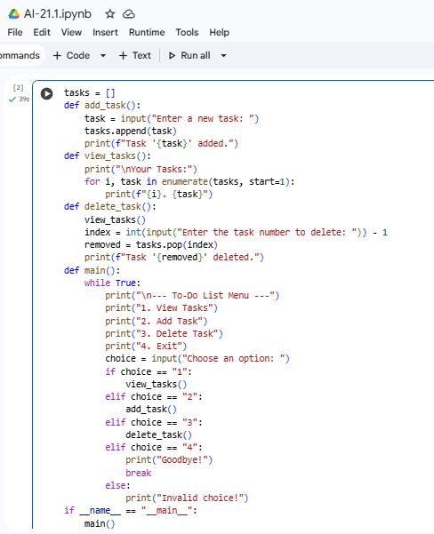  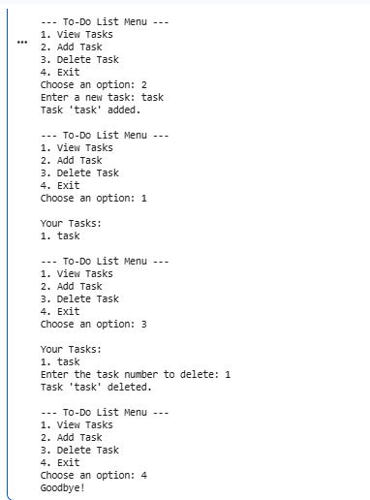  Improved version:  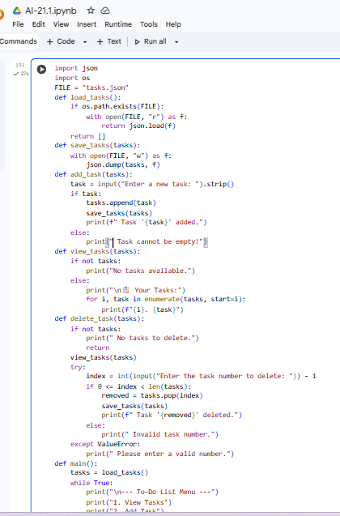  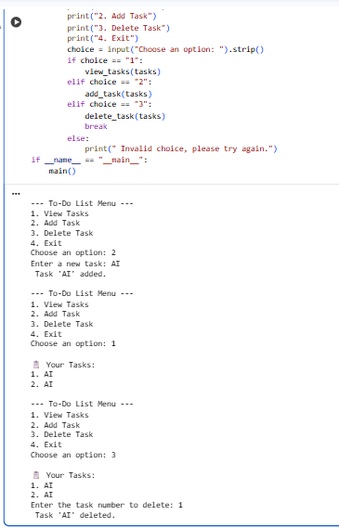  Comparison:  1.The original code is basic, while the AI version is cleaner and more organized.  2.AI adds extra features that the original program doesn’t include.  3.The AI-improved version handles errors better and works more smoothly.  Task 2 – Version Control Integration  - Initialize a Git repository for your project.  - Perform the following steps:  - Create and switch to a new branch.  - Add AI-assisted modifications.  - Commit with a meaningful message.  - Merge changes back into the main branch.  - Reflect on how version control supports collaborative development with AI assistance.  Prompt:  Give me the steps to initialize Git, create a branch, add AI-assisted changes, commit, and merge back to main. Also explain how Git helps collaboration with AI.  Code:  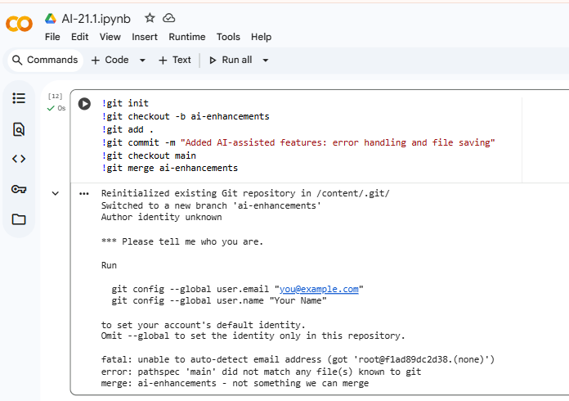  Reflection:  1.Version control allows human developers to manage and validate AI-generated code safely.  2.Branching lets teams experiment with AI suggestions without risking the main project.  3.Merging ensures only reviewed and approved AI-assisted changes become part of the final codebase.  Task 3 – AI for Commit Message Generation  - Use AI to generate concise, meaningful commit messages based on the changes made.  - Compare AI-generated messages with human-written ones.  - Discuss how AI can improve documentation and traceability in Git history.  AI-Generated:  1.Clear and descriptive about the exact changes made.  2.Consistent in style, structure, and detail.  3.Improves documentation by explaining what and why something was changed.  Human-Written:  1.Often short and vague.  2.May miss important details about what changed.  3.Style and clarity can vary from person to person.  How AI can improve documentation and traceability  AI improves documentation and traceability in Git history by automatically generating clear commit messages, summarizing code changes, linking commits to tasks or issues, and creating consistent documentation that makes it easier to track and understand project progress.  Task 4 – Pair Programming Simulation  - Student A writes the initial version of a program.  - Student B, with AI assistance, suggests improvements or adds features.  - Both students collaborate using Git branching and merging to integrate their work.  Prompt:  Simulate pair programming where Student A writes a basic program and Student B, with AI assistance, improves it by adding features or fixing issues.  Code:  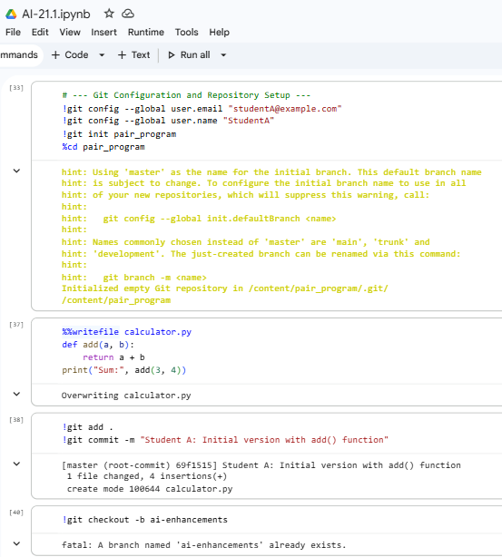  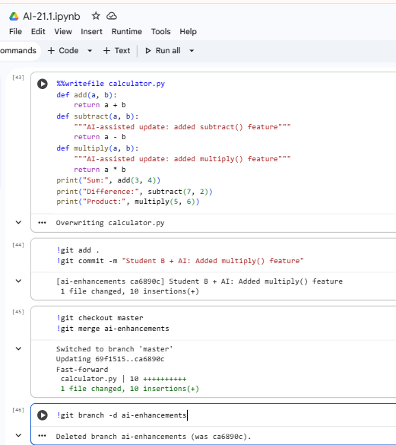  ✅ Deliverables (For All Tasks)  - AI-generated prompts for code and test case generation.  - At least 3 assert test cases for each task.  - AI-generated initial code and execution screenshots.  - Analysis of whether code passes all tests.  - Improved final version with inline comments and explanation.  - Compiled report (Word/PDF) with prompts, test cases, assertions, code, and output. |  |  |  |  |  | Week11 - Monday

